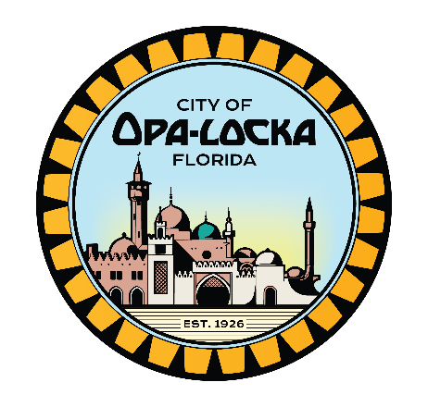

PUBLIC NOTICE
COMMUNITY RELATIONS, RECREATIONS AND ACTIVITIES BOARD

NOTICE IS HEREBY GIVEN that the Opa-locka Community Relations, Recreation and Activities Board will meet on Tuesday, June 20, 2023, at 6:00p.m. in the City Commission Chambers, Opa-Locka Municipal Complex, 780 Fisherman St., 3r^{d} Floor, Opa-Locka, Florida 33054. The purpose of the meeting is to discuss the following:
- Parks Director Report
- Playground Replacement and Repair
- Funding proposal from Interim City Manager
- Police Department

